Swiss TPH Study Number: PRR-09-2021-SSA

Determination of *in vitro* killing profile for MMV025100-09

Study Report

|  |  |
| --- | --- |
| Author: | Annabelle Walz |
| Release Date: | 27th of January 2022 |
| Study Commenced: | 3rd of October 2021 |
| Study Completed: | 29th of October 2021 |

# CONTACTS





|  |  |
| --- | --- |
| **Swiss Tropical and Public Health Institute**  Socinstrasse 57  4002 Basel  Switzerland  www.swisstph.ch  **Annabelle Walz**  Scientific Collaborator  Medical Parasitology and Infection Biology  Parasite Chemotherapy Unit  Tel.: +41 61 284 88 23  E-mail: [annabelle.walz@swisstph.ch](mailto:) | **Medicines for Malaria Venture**  Route de Pré-Bois 20  1215 Geneva  Switzerland  [www.mmv.org](http://www.mmv.org)  **Maëlle Duffey**  Research Scientist  Research & Development  Drug Discovery  Tel.: +41 79 608 17 35  E-mail: [duffeym@mmv.org](mailto:duffeym@mmv.org) |

Team members involved in the study

|  |  |
| --- | --- |
| **Function** | **Person(s)** |
| **Principal investigator (Swiss TPH)** | Dr. Sergio Wittlin |
| **Experimental technicians (Swiss TPH)** | Sibylle Sax, Annabelle Walz |
| **Project Director (MMV)** | Dr. Didier Leroy |
| **Research Scientist (MMV)** | Dr. Maëlle Duffey |



_______________________ **Date:** 27th of January 2022 **Signature of the author**

SUMMARY

In this study, the *in vitro* killing profile of MMV025100-09 has been determined using the parasite reduction ratio (PRR) assay. Being based on limiting dilution and consecutive re-growth of parasites, this assay allows assessing parasite viability following various days of drug exposure.

For this, cultures of *Plasmodium falciparum* strain NF54 were incubated with the test compound(s) or the compound control Pyrimethamine at $10×$ the 50% inhibitory concentration ($IC_{50}$). At 0, 24, 48, 72, 96, and 120 hours, an aliquot of the culture was taken and washed three times in medium. Drug-free samples were serially diluted and incubated in 96-well plates for up to 14 days in order to allow viable parasites to resume growth. Parasite growth was confirmed using [3H]hypoxanthine and filter mat readout. For each time point, the number of viable parasites was then extrapolated from the number of wells rendering parasite growth.

The resulting killing curve allows to determine parameters describing the mode of action of the given compound, such as lag phase (time needed to observe parasite decline), PRR (Parasite Reduction Ratio in log10) and the 99.9% parasite clearance time (${PCT}_{99.9\%}$).

MMV025100-09 displays a slow killing profile best comparable that of Atovaquone; it does not result in complete killing after 120 hours of drug pressure.

# Materials

## Compounds

In this campaign, the following compounds were tested at concentrations based on published and here reported $IC_{50}$ values:

* MMV025100-09, $IC_{50}$ NF54 (72h 3HH) = 167.9 nM
* MMV000024-16 (Pyrimethamine control), $IC_{50}$ NF54 (72h 3HH) = 17 nM (2)

## Reagents and Consumables

**Table 1:** Reagents, their origin and reference number.

|  |  |
| --- | --- |
| **Reagent/Consumable** | **Origin (Reference No.)** |
| **RPMI Medium 1640** | Life technologiesTM (51800-043) |
| **HEPES** | Sigma Life Science (H4034) |
| **albuMAXTM II** | Thermo Fisher Scientific (11021-045) |
| **neomycin powder** | Sigma Life Science (N6386) |
| **sodium bicarbonate** | Sigma Aldrich (31437-500G-R) |
| **hypoxanthine** | Sigma Life Science (H9377) |
| **hypoxanthine [8-3H]** | American Radiolabeled Chemicals (0266) |
| **BETAPLATE SCINT** | Perkin Elmer (1205-440) |
| **Dimethyl sulfoxide** | Sigma Aldrich (41640) |
| **96-well plates** | Sarstedt (83.3924) |
| **6-well plates** | Sarstedt (83.3920) |

## Recipes

**Table 2:** Recipes for the solutions used in this study.

|  |  |
| --- | --- |
| **Solution** | **Ingredients** |
| **screening medium** | RPMI 1640 (10.44 g/l) supplemented with HEPES (5.94 g/l), NaHCO3 (2.1 g/l), Neomycin (100 µg/ml), and albuMAXTM II (5 g/l) |
| **culture medium** | RPMI 1640 (10.44 g/l) supplemented with HEPES (5.94 g/l), NaHCO3 (2.1 g/l), Neomycin (100µg/ml), hypoxanthine (50 mg/l), and albuMAXTM (5 g/l) |
| **[3H]hypoxanthine** | 5 mCi/5 ml stocks diluted 1:2 in 50% Ethanol; aliquots of 0.5 ml are then diluted 1:100 in screening medium |

# Experimental procedure

## Determination of $IC_{50}$ values

The initial compound concentration used in the PRR assay is based on the dose-response curve generated with the *Plasmodium falciparum* growth inhibition assay. It equals $10×IC_{50}$ (1).

The *Plasmodium falciparum* growth inhibition assay is used to determine the $IC_{50}$ of a given compound in accordance with Snyder et al. (2007) (3). In brief, naïve parasites of strain NF54 (BEI Resources, accession no. MRA-1000) are exposed to a serial dilution of compounds for 72 hours. The readout method is based on incorporation of radiolabelled hypoxanthine into the parasites DNA, which serves as indicator of parasite growth (4).

For details, see the attached PDF file.

0 determination.pdf”). 

## Parasite Reduction Ratio Assay

### Compound Preparation

Compounds are dissolved in DMSO or other solvent (if insoluble) to obtain a 10 mM stock. Stocks are stored at 4°C for ≥ 2 weeks. Working dilutions are 100-fold concentrated and must be prepared freshly in culture medium.

### Assay Procedure

An unsynchronized *P. falciparum* culture, strain NF54, is adjusted to 0.3% parasitaemia and 1.25% hematocrit (corresponding to growth inhibition assay conditions) using fresh human erythrocytes and culture medium. To initiate the assay, culture aliquots are incubated with fresh compound solution at 37°C and 93% N2, 4% CO2, and 3% O2. Culture medium and compound are replenished every 24 hours. Untreated cultures (0, 24, and 48 hours incubation) serve as growth controls.

Before the first treatment (0 hours) and after 24, 48, 72, 96 and 120 hours, 3 ml of culture are sampled from the corresponding well and compound is removed by washing three times in 3 ml of culture medium (centrifugation: 2 min, 600 x g). In a 96-well plate, four technical replicates of each sample (eight for growth controls) are serially diluted by factor four before incubating again for up to 14 days. Once a week, culture medium is replenished and fresh erythrocytes are provided. After 13 days, the medium is replaced with [3H]hypoxanthine in screening medium, before freezing the plates 24 hours later at -20°C.

Thawed plates are harvested with a BetaplateTM cell harvester (Wallac, Zurich, Switzerland), which transfers the lysed red blood cells onto a glass fiber filter. The dried filters are inserted into a plastic foil with 10 ml of scintillation fluid and counted in a BetaplateTM liquid scintillation counter (Wallac, Zurich, Switzerland). The results are recorded as counts per minute (cpm). In addition, colored spots on the dry filter mat are recorded. They serve as visual indicator for parasite growth.

The reference compound MMV000024 (Pyrimethamine) is included in every campaign at $10×IC_{50}$ to validate the experiment.

### Data Analysis

For each technical replicate of a sample, the number of viable parasites is extrapolated using the following equation:

$P_{viable}=\left\{\begin{aligned}X^{n-1} if &n≥1 \\ 0 if &n=0\end{aligned}\right.$ eq. (1)

where $P_{viable}$ represents the number of viable parasites, $X$ the dilution factor used for serial dilution, and $n$ the number of wells with detected parasite growth (1). In the case of $n = 0$, the number of viable parasites is considered to be zero.

The number of viable parasites at each sample time is then normalized as follows:

$$\left\{\begin{matrix}\log_{10}\left({\overline{P}}_{viable}\left(t\right)+1\right) & = & N_{0}⋅\log_{10}\left(P_{viable}\left(t\right)+1\right) \\ N_{0} & = & \frac{5}{\log_{10}\left(P_{viable}\left(t=0h\right)+1\right)}\end{matrix}\right.$$

where $N_{0}$ is the normalization factor and ${\overline{P}}_{viable}\left(t\right)$ the normalized level of parasites. This normalization corrects $P_{viable}\left(t=0h\right)$ such that it equals ~105 parasites in a 267 μl sample from a culture of 0.3% parasitaemia and 1.25% hematocrit, and enables comparison between different experiments (1).

The normalized data is then analyzed in R (version 4.0.3) to derive the growth rate, the lag phase, the rate of parasite decline, the PRR and the 99.9% parasite clearance time.

The lag time and rate of parasite decline is estimated for each compound assuming non-linear relationship between duration of exposition to a given compound $t$ and number of viable parasites ${\overline{P}}_{viable}$.The formula consists of a lag phase, a linear phase and a tail phase expressed as:

$f\left(t\right)=\min\left(5,\max\left( -a⋅\left(t-lag\right)+5, minima\right)\right)$ eq. (2)

where $f\left(t\right)$ equals to $\log_{10}\left({\overline{P}}_{viable}+1\right)$, and $a$ represents the parasite decline rate, $lag$ the lag phase and $minima$ the tail taken as the minimum average $\log_{10}\left({\overline{P}}_{viable}+1\right)$ (however, if the drop $\log_{10}\left({\overline{P}}_{viable}+1\right)$ between 96 and 120 hours is larger than the average standard deviation, $minima$ is fixed to 0).

The parameters $a$ and $minima$ of the non-linear model are estimated using the non-linear least squares function nls of R for various fixed lag time $lag$ (0, 6, 12, 18, […], 72 hours). The model with the best fit (*i.e.* smallest σ value) is considered as final, unless one of four so-called ’dominant rules‘ applies (see chapter 5.3, Appendix).

From the best model fit, $lag$ and $a$ are extracted and used to estimate PRR, maximum killing rate and the 99.9% parasite clearance time. They allow discriminating compounds based on their potency levels (1, 5).

The parasite reduction ratio PRR, defined as the log10 drop of viable parasites within 48 hours, can be calculated as:

$PRR =a⋅48h$ eq. (3)

The 99.9% parasite clearance time $PCT_{99.9\%}$, defined as the time to kill 99.9% of parasites by the drug, *i.e. $t$* such as $f\left(t\right)=2$ (eq. 2), can be calculated as:

${PCT}_{99.9\%}=\frac{3}{a}+lag$ eq. (4)

The PRR and $lag$ are used to assign a compound to one of five possible killing profiles ranging from ‘slow’ to ‘fast’ pharmacodynamic categories. Hence, a compound can be categorized as ‘fast’ ($PRR ≥ 4$, $lag = 0h$), ‘fast with lag phase’ ($PRR ≥ 4$, $lag > 0h$), ‘intermediate’ ($3 ≤ PRR < 4$, $lag = 0h$), ‘intermediate with lag phase’ ($3 ≤ PRR < 4$, $lag > 0h$), or ‘slow’ ( $PRR < 3$ or $lag > 48h$).

## Quality Controls

### Compound Stability

Throughout the whole treatment period, compound is replenished every 24 hours in order to maintain an overall high compound concentration.

To assess compound stability, supernatant is collected 24 hours after the first treatment. Compound solution used for initiation of the assay (0 hours) is also collected and serves as a reference. In a 96-well plate, naïve *P. falciparum* parasites (strain NF54) are then exposed to a serial dilution of compound solution or supernatant at 1.25% haematocrit and 0.3% parasitaemia. Untreated parasites are included as positive control, whereas 1.25% uninfected red blood cells serve as negative control. Plates are incubated at 37°C and 93% N2, 4% CO2, and 3% O2. After 48 hours, radiolabelled hypoxanthine is added, before freezing the plates at -20°C another 24 hours later. Thawed plates are harvested as described in chapter 2.2 and normalized counts are used to calculate the $IC_{50}$. Fold-changes of $IC_{50}$ values between reference and 24 hours supernatant inform about concentration changes.

Compound Washout

The compound washout assay shall assure that all compound was fully removed from the sample before performing the serial dilution in 96-well plates. This avoids overestimation of compound potency caused by an inhibiting effect of drug remnants on the parasites.

The washout sample is collected during the treatment period of the PRR assay. After 24 hours of treatment, an aliquot of the treated culture is washed at least three times in culture medium. After the second last washing step, 1 ml of supernatant is collected and diluted in accordance with the actual PRR sample. Thereby, further dilution within the compound washout assay must be considered. Naïve *P. falciparum* parasites (strain NF54) are then exposed to a serial dilution of this supernatant at 1.25% haematocrit and 0.3% parasitaemia. Untreated parasites are included as positive control, whereas 1.25% uninfected red blood cells serve as negative control. Cultures are incubated at 37°C and 93% N2, 4% CO2, and 3% O2. After 48 hours, radiolabelled hypoxanthine is added, before freezing the plates at -20°C another 24 hours later. Thawed plates are harvested as described in chapter 2.2 and normalized counts are used to calculate the $IC_{50}$. Successful washout is observed when growth of supernatant-treated parasites is comparable to that of the untreated controls.

### Growth Control

Untreated controls sampled at 0, 24, and 48 hours allow monitoring parasite growth.

# Results

## Determination of $IC_{50}$ Values

The $IC_{50}$ values were determined using freshly prepared compound stocks. For MMV025100-09, the here reported $IC_{50}$ value was used in the PRR assay, whilst for Pyrimethamine, the published value was used (2).

**Table 3:** Average [minimum, maximum] $IC_{50}$ values generated with the in vitro growth inhibition assay ([3H]hypoxanthine, 72h) from ≥ two biological replicates are indicated in brackets. Chloroquine diphosphate served as internal control.

|  |  |  |  |
| --- | --- | --- | --- |
| **MMV ID** | **Compound name** | **Published/provided $IC_{50}$ (nM)** | **Measured average $IC_{50}$ [min, max] (nM)** |
| MMV025100-09 | OSM-S-106 | NA | 167.9 [154, 181.8] |
| MMV000024-16 | Pyrimethamine | 17 | 18.3 [17.5, 19.2] |
| MMV000008-29 | Chloroquine diphosphate | 11.2 | 8.4 [8, 8.8] |

## Killing Curves and Parameters

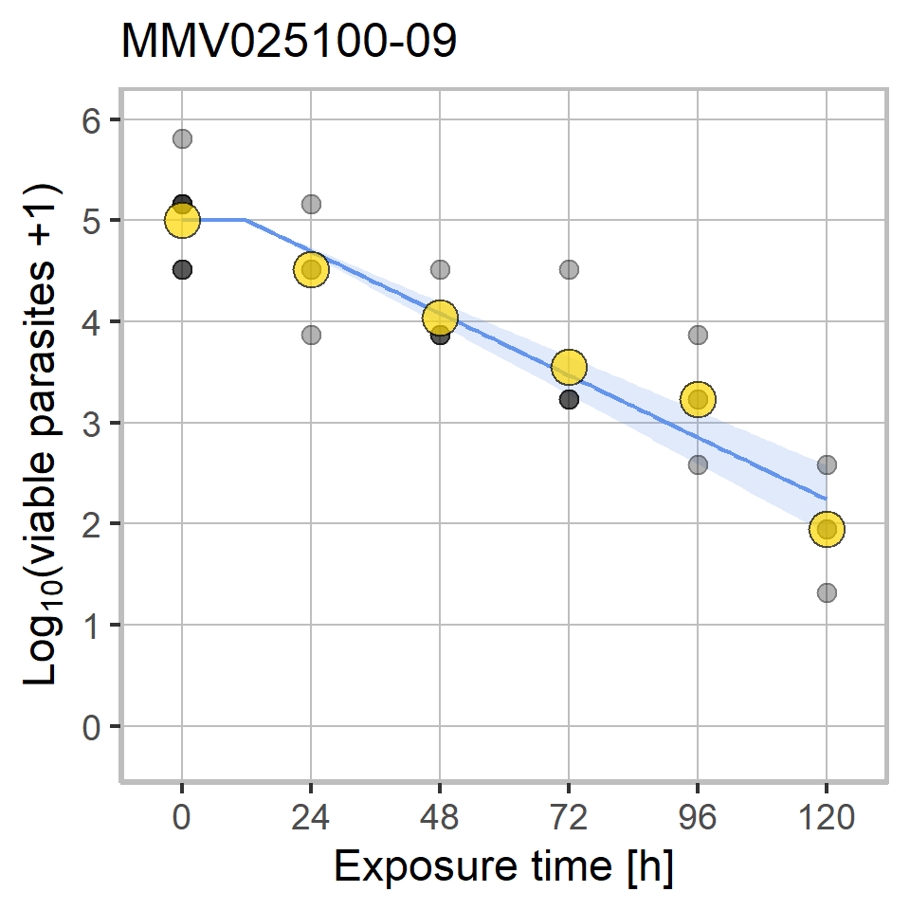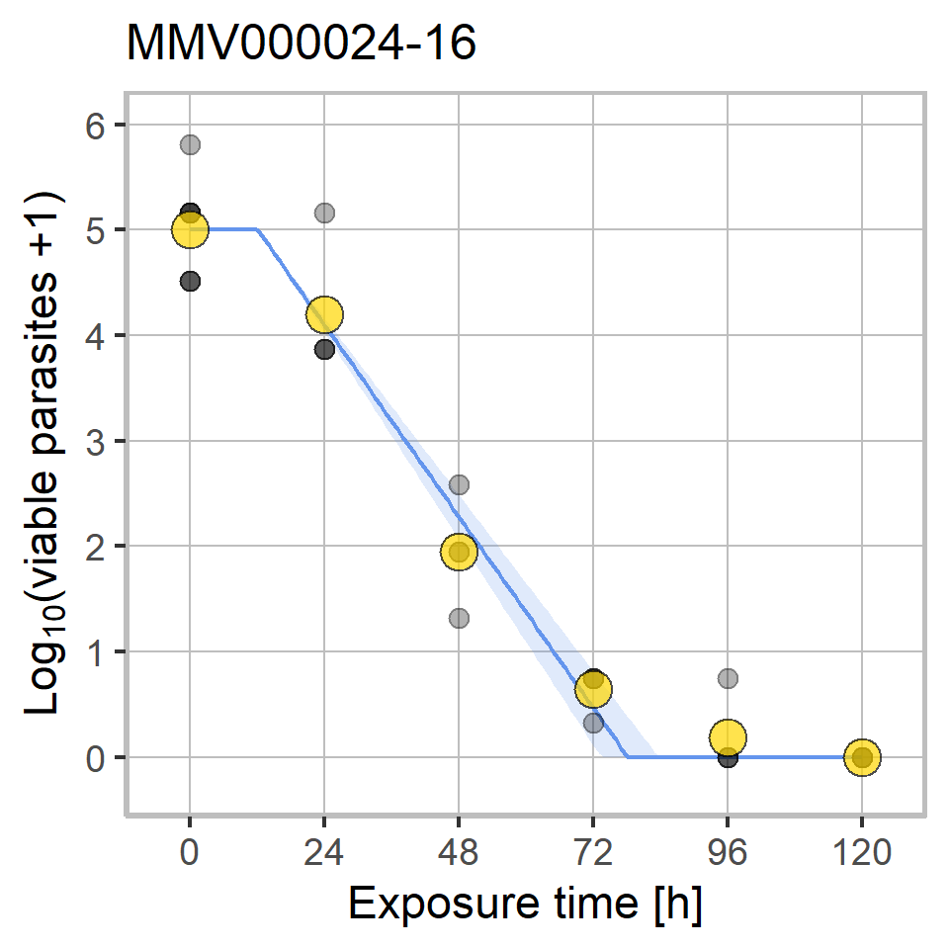

**Figure 1:** Killing curves of MMV025100-09 and MMV000024-16 (Pyrimethamine) at $10×IC_{50}$ over a period of 120 hours. Dots represent the experimental data with the mean values coloured in yellow and individual replicates coloured in grey with darker shades indicating > 1 overlapping replicates; red dots indicate a difference between mean and estimated curve higher than the average standard deviation or a standard deviation larger than two times the average standard deviation ; the blue ribbon marks the 95% confidence interval of the fitted curve.

**Table 4:** Killing curve parameters for MMV025100-09 and the control MMV000024-16 (Pyrimethamine). Lag phase is the calculated lag phase with the 24 hours range in brackets; the standard deviation σ describes the goodness of the fit of the model with a value of zero representing a perfect fit. The 95% confidence intervals (all others) are reported in brackets if not indicated otherwise.

|  |  |  |  |
| --- | --- | --- | --- |
|  | MMV025100-09 | | Pyrimethamine |
| $IC_{50}$**[μM]** | | 0.168 | 0.017 |
| **Multiple of $IC_{50}$** | | 10 | 10 |
| **Category** | | slow | intermediate with lag phase |
| **Lag phase [h]** | | 12 [0 - 24] | 12 [0 - 24] |
| **PCT99.9% [h]** | | >120 | 51.7 [48.8 - 55] |
| **PRR** | | 1.2 [1.1 - 1.4] | 3.6 [3.3 - 3.9] |
| **σ** | | 0.492 | 0.422 |

# Discussion

MMV025100-09 displays a slow killing profile best comparable that of Atovaquone and does not result in complete killing after 120 hours of drug pressure (Figure 2). It has a lag phase of 12 [0 - 24] hours, a PRR of 1.2 [1.1 - 1.4], and a PCT99.9% > 120 hours.

The compound is stable over a period of 24 hours and was fully removed after washing three times in culture medium.

Results for Pyrimethamine were comparable with reference data (Figure 3), thereby validating the results of this experiment.

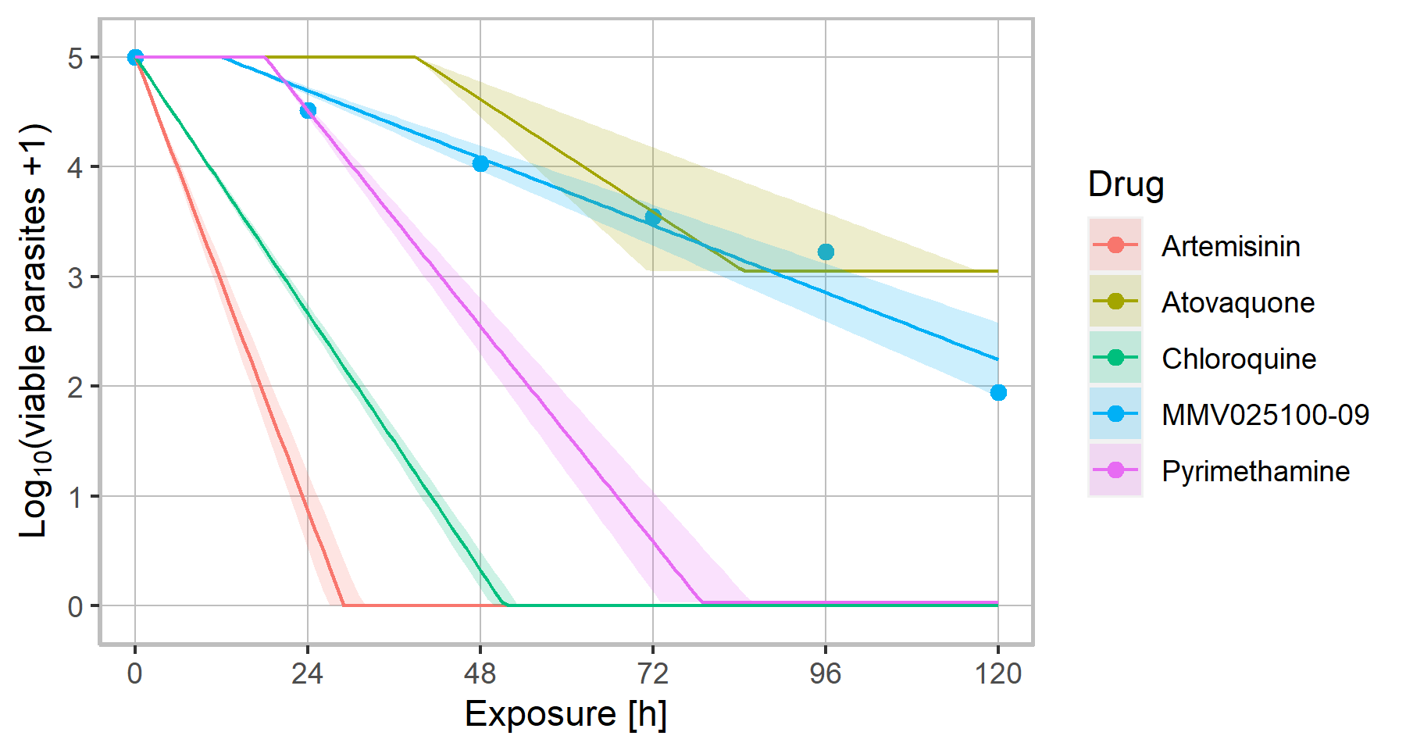

**Figure 2:** Comparison of killing profiles between compound MMV025100-09 (blue) and the reference compounds Artemisinin, Atovaquone, Chloroquine, and Pyrimethamine tested at $10×IC_{50}$. Killing curves of the reference compounds are based on ≥ 3 biological replicates. Dots are the mean values of the measurements. Ribbons indicate 95% confidence intervals.

# Appendix

## Quality Controls

### Pyrimethamine Control

Pyrimethamine was included as a compound control to assure that parasite killing appeared as expected. In comparison with the reference curve (Figure 3), the Pyrimethamine curve from this campaign shows no remarkable difference.

A stage effect can be seen by means of a small lag phase, thereby reflecting the high proportion of ring stages in the initial parasite population.

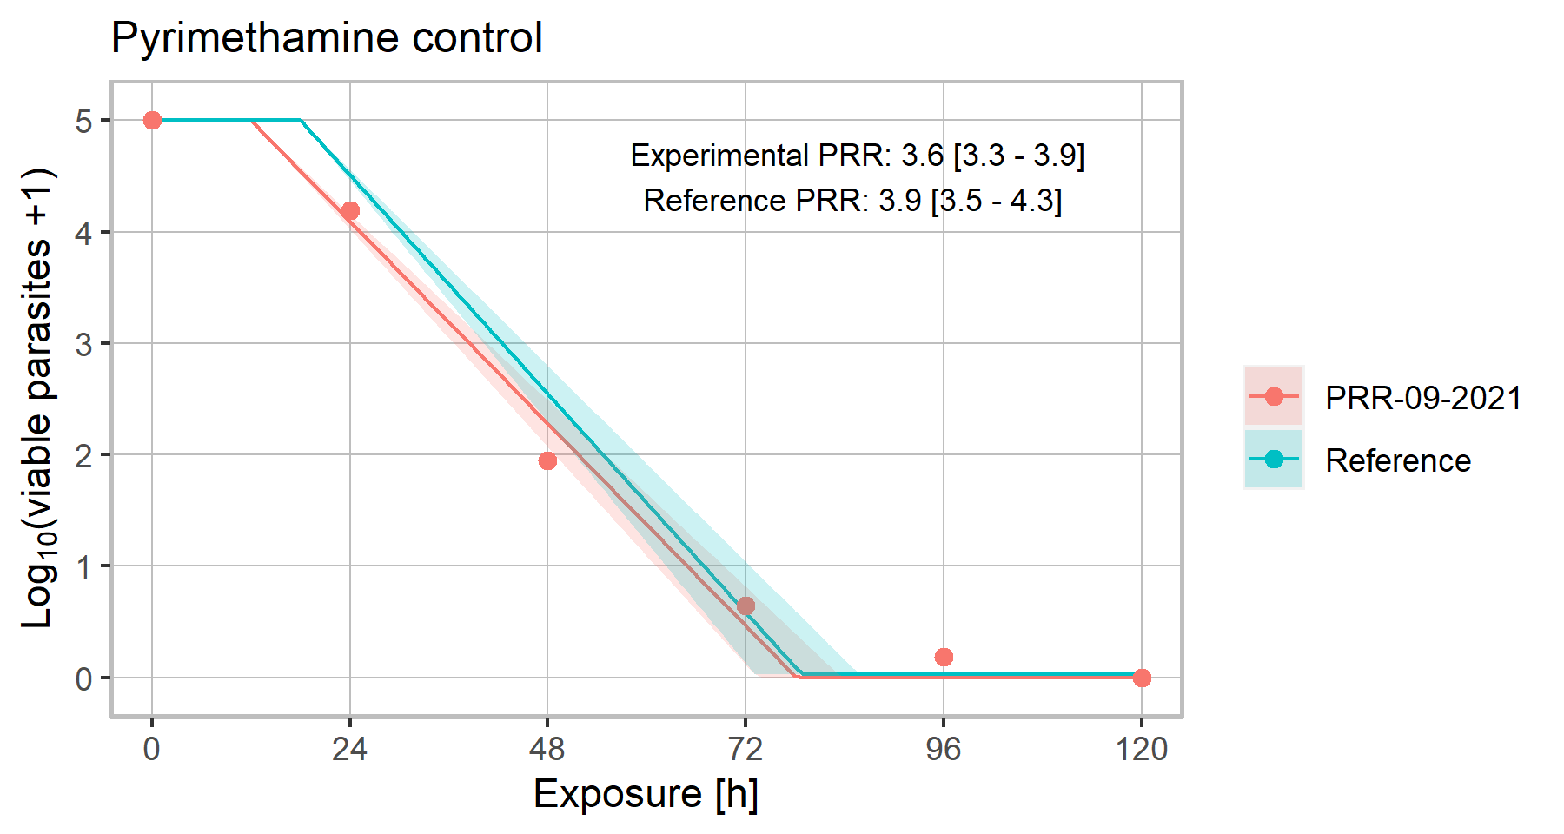

***Figure 3:*** *Comparison between the experimental Pyrimethamine tested in this campaign (MMV000024-16, in red) and the reference curve obtained from > 10 biological replicates (in blue).*

Other Controls

**Table 5:** Results for growth controls, compound stability and compound washout assessment.

|  |  |  |
| --- | --- | --- |
| Type of control | Results | Comment |
| **Growth Controls** |  | Normal parasite growth. |
| **Compound Stability** |  | Stable over a period of 24 h. |
| **Compound Washout** |  | Washout successful. |

## Killing Curve Parameters

For a full list of killing curve parameters, see the embedded Excel file.



## Dominant rules for lag phase determination



## Estimates of Viable Parasites

**Table 6:** Quantification of viable parasites for MMV025100-09 and MMV000024-16 (Pyrimethamine) at a concentration of $10×IC_{50}$.

|  |  |  |  |  |  |  |
| --- | --- | --- | --- | --- | --- | --- |
|  | **Time (h)** | **Log10(viable parasites+1)** | **Standard deviation** | **Normalization Factor** | **Log10(viable parasites+1) normalized** | **Standard deviation normalized** |
| **MMV025100-09** | 0 | 4.67 | 0.43 | 1.0716 | 5.00 | 0.46 |
| 24 | 4.21 | 0.49 | 4.52 | 0.53 |
| 48 | 3.76 | 0.30 | 4.03 | 0.32 |
| 72 | 3.31 | 0.60 | 3.55 | 0.64 |
| 96 | 3.01 | 0.49 | 3.23 | 0.53 |
| 120 | 1.82 | 0.48 | 1.95 | 0.52 |
| **Pyrimethamine** | 0 | 4.67 | 0.43 | 1.0716 | 5.00 | 0.46 |
| 24 | 3.91 | 0.60 | 4.19 | 0.65 |
| 48 | 1.82 | 0.48 | 1.95 | 0.52 |
| 72 | 0.60 | 0.20 | 0.64 | 0.21 |
| 96 | 0.17 | 0.35 | 0.19 | 0.37 |
| 120 | 0.00 | 0.00 | 0.00 | 0.00 |

# References

1. Sanz LM, Crespo B, De-Cózar C, Ding XC, Llergo JL, Burrows JN, García-Bustos JF, Gamo FJ.2012. P. falciparum in vitro killing rates allow to discriminate between different antimalarial mode-of-action. PLoS One 7:e30949.

2. Delves M, Plouffe D, Scheurer C, Meister S, Wittlin S, Winzeler EA, Sinden RE, Leroy D.2012. The activities of current antimalarial drugs on the life cycle stages of Plasmodium: a comparative study with human and rodent parasites. PLoS Med 9:e1001169.

3. Snyder C, Chollet J, Santo-Tomas J, Scheurer C, Wittlin S.2007. In vitro and in vivo interaction of synthetic peroxide RBx11160 (OZ277) with piperaquine in Plasmodium models. Exp Parasitol 115:296-300.

4. Desjardins RE, Canfield CJ, Haynes JD, Chulay JD.1979. Quantitative assessment of antimalarial activity in vitro by a semiautomated microdilution technique. Antimicrob Agents Chemother 16:710-8.

5. White NJ.1997. Assessment of the pharmacodynamic properties of antimalarial drugs in vivo. Antimicrob Agents Chemother 41:1413-22.